Monster Game Engine

Visual Studio Team Services Build Tutorial

If you would like to build the Monster Game Engine using Visual Studio Team Services, then simply follow these simple instructions.

1. Click on the build tab when you have entered the project.

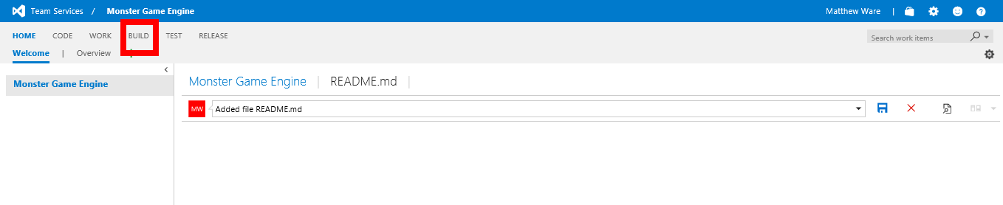

Press the link in the red box (BUILD)

1. Now you have clicked on the build tabs, open up the *Build Definitions* section by clicking on the arrow by the label.

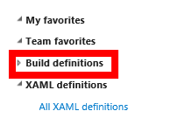

1. Once you have done that, you should click on the build definition ‘MGE Builder’.

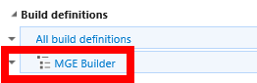

1. Once you have done that too, you now need to queue a build... Click on the queue build button.

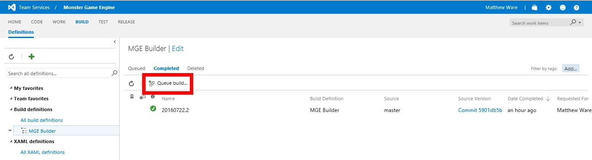

1. Now you have clicked on that, you should get a window about queueing a build for MGE.

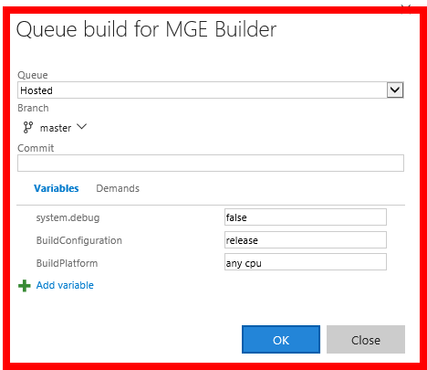

1. First, make sure all the options look like this:

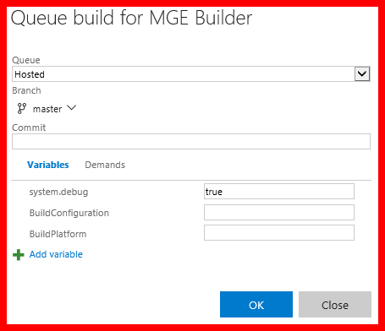

**Note:** You may need to change the three variables near the bottom, if they do not look like this, it may/will not work.

1. Click ok.

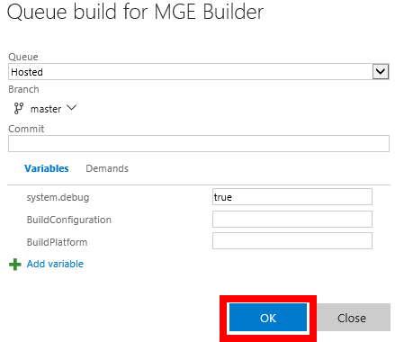

1. Now it should start building. Once it’s completed (hopefully successfully) , you’re done!

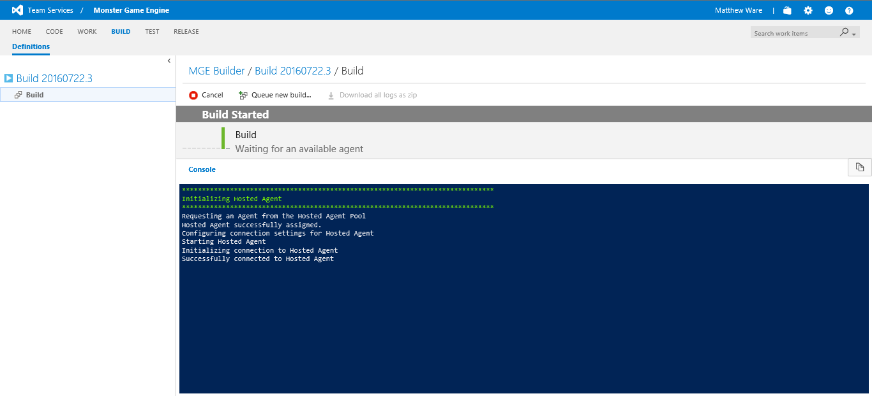

**Note:** If the build fails, then check the logs and try and repair the error. It could be a code error or a build settings error or something else. If it is a build settings error, revise the setup and re-read this tutorial.